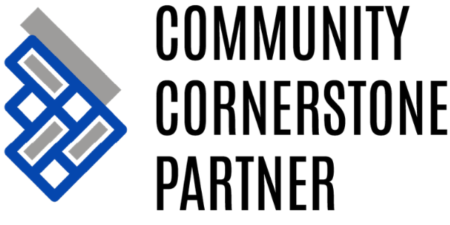

WHY BECOME A CORNERSTONE PARTNER?
Being a Cornerstone Partner gives your organization a chance to let your employees and customers know that your company cares about building a stronger community.
Check out our Cornerstone Benefits below and contact the United Way office at 715-421-0390 or at uwswac.org for more information or to become a Cornerstone Partner today!

CORNERSTONE PARTNER BENEFITS:
For Community Cornerstone Partners, we offer the following as annual recognition, according to the level of giving. Each higher level receives the benefits of all lower levels plus their own:
CONTRIBUTOR [$500-$999]
Listing on the UWSWAC Community Cornerstone webpage
BENEFACTOR [$1,000-$4,999]
Listing in the UWSWAC Annual Report
ADVOCATE [$5,000-$7,499]
Recognized at annual Thank You Celebration
STEWARD [$7,500-$9,999]
Listing on the UWSWAC Community Cornerstone webpage with link to your company website
COLLABORATOR [$10,000-$24,999]
Social media “Cornerstone Spotlight” thank you post
HERO [$25,000-$49,999]
Featured as a “Cornerstone Spotlight” in quarterly newsletter
CHAMPION [$50,000-$99,999]
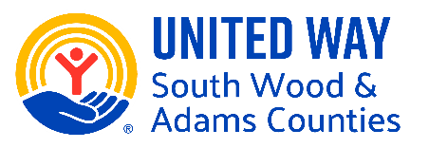
Logo on UWSWAC website homepage
TRUSTEE [$100,000+]
Corporate banner displayed at Thank You Celebration

